SPEVI Conference 2025 - Exhibitors’ Opportunities

Location
You are invited to set up an exhibition in the foyer of the conference venue at University of Southern Queensland (UniSQ) Brisbane campus, 293 Queen Street, Brisbane - a five-minute walk to Central Station and easy access to bus and ferry stops.
The exhibition space is located in the foyer on the ground floor, between the plenary seminar room and the area where conference delegates will assemble for morning and afternoon teas, lunch, and during other conference breaks, ensuring unparalleled foot traffic each day.
Maps and photos (Ground floor, section C).
UniSQ Brisbane Ground Floor map

All Exhibitor Registration Packages Include:
- An open forum with all conference delegates during the conference and during the Welcome event with movie screening of “Possibilities” (more information can be found here) on Monday evening
- Participation in an exhibitor interactive competition, for which you are invited to donate gifts promoting your product.
- Inclusion of your logo on the SPEVI 2025 Conference website
- Acknowledgement in the digital conference book (1/4 A4)
- Trestle tables and chairs to allow you to display banners, resources and equipment.
Please select from the following 2 exhibition options.

Level 2 Exhibitor Registration Package ($2250) also includes:
- Full conference registration for two representatives for Monday, Tuesday, and Wednesday including lunch on each of these days, the Welcome event with movie screening of “Possibilities” (Monday night) and Conference Dinner (Brisbane River Dinner Cruise).
- A double length display table (with access to power)

Level 1 Exhibitor Registration Package ($1250) also includes:
- Full conference registration for one representative for Monday, Tuesday, and Wednesday including lunch on each of these days, the Welcome event with movie screening of “Possibilities” (Monday night). Please note, this does not include the Conference Dinner Cruise.
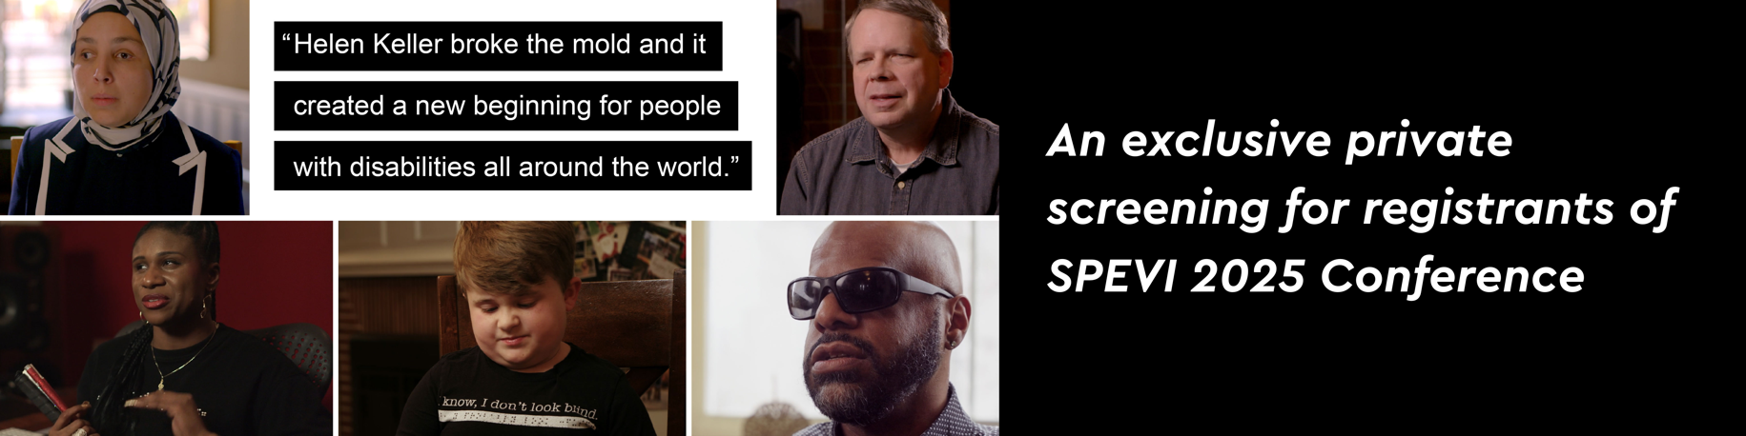
- A single length display table (with access to power)

“Possibilities is a documentary film celebrating the legacy of Helen Keller as told through the shared stories of 21st-century voices. Possibilities is a co-production of the American Foundation for the Blind (AFB) and BeachGlass Films. The film’s director, Bill Sarine, brought together a collaborative team comprised of both blind and sighted individuals. The full-length documentary proudly stands as the first widely released film to offer open audio description, ensuring accessibility for all audiences.”

To watch the trailer, click here: https://youtu.be/LAtNeaxzHew?si=QrwIGmO_MO5CD8PP

This is a free event for registrants of the SPEVI 2025 Conference. For all details, please refer to the website: https://www.speviconference.net/registration/

For inquires, please contact: admin@speviconference.net

