## Sponsorship Opportunities SPEVI 2025 Conference

#SPEVI 2025 - Em*POWER*ment through connection, inclusion and education.

Sponsorship of the SPEVI 2025 Conference will provide your organisation or company with an opportunity to be associated with the highlight on the calendar of people dedicated to supporting and advocating for equitable education of students with blindness or low vision in Australia, New Zealand and the South Pacific countries.

## Who is SPEVI?

The South Pacific Educators in Vision Impairment (SPEVI Inc) is the major professional association for educators of students with vision impairments in Australia, New Zealand and the South Pacific region and the leading professional body to advocate for excellence and equity in education for students with blindness and low vision, including deafblindness and multiple disabilities.

## Where will the conference be held?

The SPEVI 2025 Conference will be held as a hybrid event, meaning it will offer the opportunity for online participation as well as in-person participation in Brisbane, at University of Southern Queensland (UniSQ) Brisbane campus, 293 Queen Street, Brisbane - a five-minute walk to Central Station and easy access to bus and ferry stops.

*This hybrid platform means extended reach and exposure for sponsors of the event

## Benefits from sponsorship

Sponsors receive the following benefits plus those listed with each sponsorship level:

* Acknowledgement and a link to your organisation’s website on the SPEVI 2025 Conference website.
* Acknowledgments of all sponsors on the opening slide of each day of the conference.
* Inclusion of handouts and resources in digital conference book.
* Opportunity to provide custom gifts to the conference attendees.

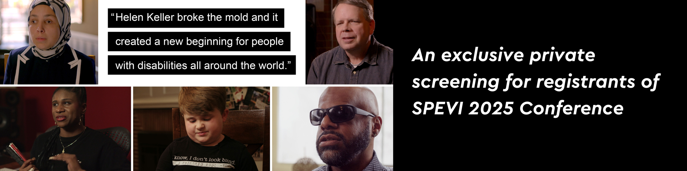

## “Possibilities is a documentary film celebrating the legacy of Helen Keller as told through the shared stories of 21st-century voices. Possibilities is a co-production of the American Foundation for the Blind (AFB) and BeachGlass Films. The film’s director, Bill Sarine, brought together a collaborative team comprised of both blind and sighted individuals. The full-length documentary proudly stands as the first widely released film to offer open audio description, ensuring accessibility for all audiences.”

## To watch the trailer, click here: [https://youtu.be/L](https://youtu.be/LAtNeaxzHew?si=QrwIGmO_MO5CD8PP)[AtNeaxzHew?si=QrwIGmO_MO5CD8PP](https://youtu.be/LAtNeaxzHew?si=QrwIGmO_MO5CD8PP)

## This is a free event for registrants of the SPEVI 2025 Conference. For all details, please refer to the website: <https://www.speviconference.net/registration/>

## Suggested Sponsorship Levels

### Diamond $5,000.00

* Acknowledgement as a diamond conference sponsor in all marketing collateral and inclusion of your corporate logo on promotional material and social media.
* An opportunity for exclusive recognition through the provision of lanyards for delegate’s name badges.
* An opportunity to present the inaugural SPEVI Frances Gentle Award for Innovations in Professional Learning (Early Career or Established Career at the Conference.
* Two complimentary conference registrations.
* Short address to delegates at the conference
* An opportunity to display your banner at the conference.
* Acknowledgement in the digital conference book (1/2 A4) with an introductory paragraph about your organisation.

### Platinum $3,000.00

* An opportunity to be named as an official Conference Dinner Cruise sponsor.
* One complimentary conference registration, including Conference Dinner Cruise
* An opportunity to address delegates at the Conference Dinner Cruise.
* An opportunity to display your banner at the conference.
* Acknowledgement in the digital conference book (1/2 A4)

### Gold $2,000.00

* An opportunity to be named as official sponsor of a Conference Lunch
* An opportunity to display your banner at the conference.
* Acknowledgement in the digital conference book (1/4 A4)

### Silver $1,000.00

* An opportunity to be named as official sponsor of aConference Coffee/Tea
* Acknowledgement in the digital conference book

### Bronze $100

* Acknowledgement and inclusion of your corporate logo with link to your organisation on the SPEVI 2025 Conference website

### Bespoke sponsorship

All sponsorship opportunities can be customised to suit your organisation’s specific requirement including naming rights to conference rooms, keynote presentations and concurrent sessions, provision of products with your company logo & SPEVI conference 2025, including 400 bottles of water, 200 lanyards and 200 coffee keepsake cups.

Contact us to decide the best sponsorship opportunities for you: [admin@speviconference.net](mailto:admin@speviconference.net?subject=SPEVI%202025%20Sponsorship%20Inquiry)